**Veer Narmad South Gujarat University, Surat.**

**Department of Information and Communication Technology**

**M.Sc. (Information and Communication Technology) Programme**

Project Report

**2nd Semester**

**M.Sc. (Information and Communication Technology)**

**2 Year Course**

**Year 2022 – 2023**

Cooking Hub

|  |  |
| --- | --- |
| Guided By :  **Rahul Ladumor (External Guide)**  **Dr. Pushpal Desai (Internal Guide)** | Submitted By :  **Neel Chodvadiya (R22110018000710008)** |

FameUX Technologies LLP

704, 7th Floor, AP MC, Krushi Bazaar, Sahara Darwaja, Begampura, Surat, Gujarat 395002

**Veer Narmad South Gujarat University, Surat.**

**Department of Information and Communication Technology**

**M.Sc. (Information and Communication Technology) Programme**

**Certificate**

This is to certify that Mr./Ms. **Neel Suresh Bhai Chodvadiya** with Exam Seat Number: **10021** and Enrollment Number: **R22110018000710008** has worked on his/her part time project work entitled **Cooking Hub** at **FameUX Technologies LLP** as a partial fulfillment of the requirements for 2nd ***Semester - M.Sc. (Information and Communication Technology)***, during the academic Year 2022-2023.

Date :

Place : Dept. of ICT, VNSGU, Surat.

|  |  |  |
| --- | --- | --- |
| **Internal Project Guide**  **M.Sc.(I.C.T.) 2nd Semester**  **Department of I.C.T.**  **Veer Narmad** **South Gujarat University, Surat** | **Course Coordinator**  **M.Sc. (I.C.T.) Programme**  **Department of I.C.T.**  **Veer Narmad** **South Gujarat University, Surat** | **Head of the Department**  **Department of I.C.T.**  **Veer Narmad** **South Gujarat University, Surat** |

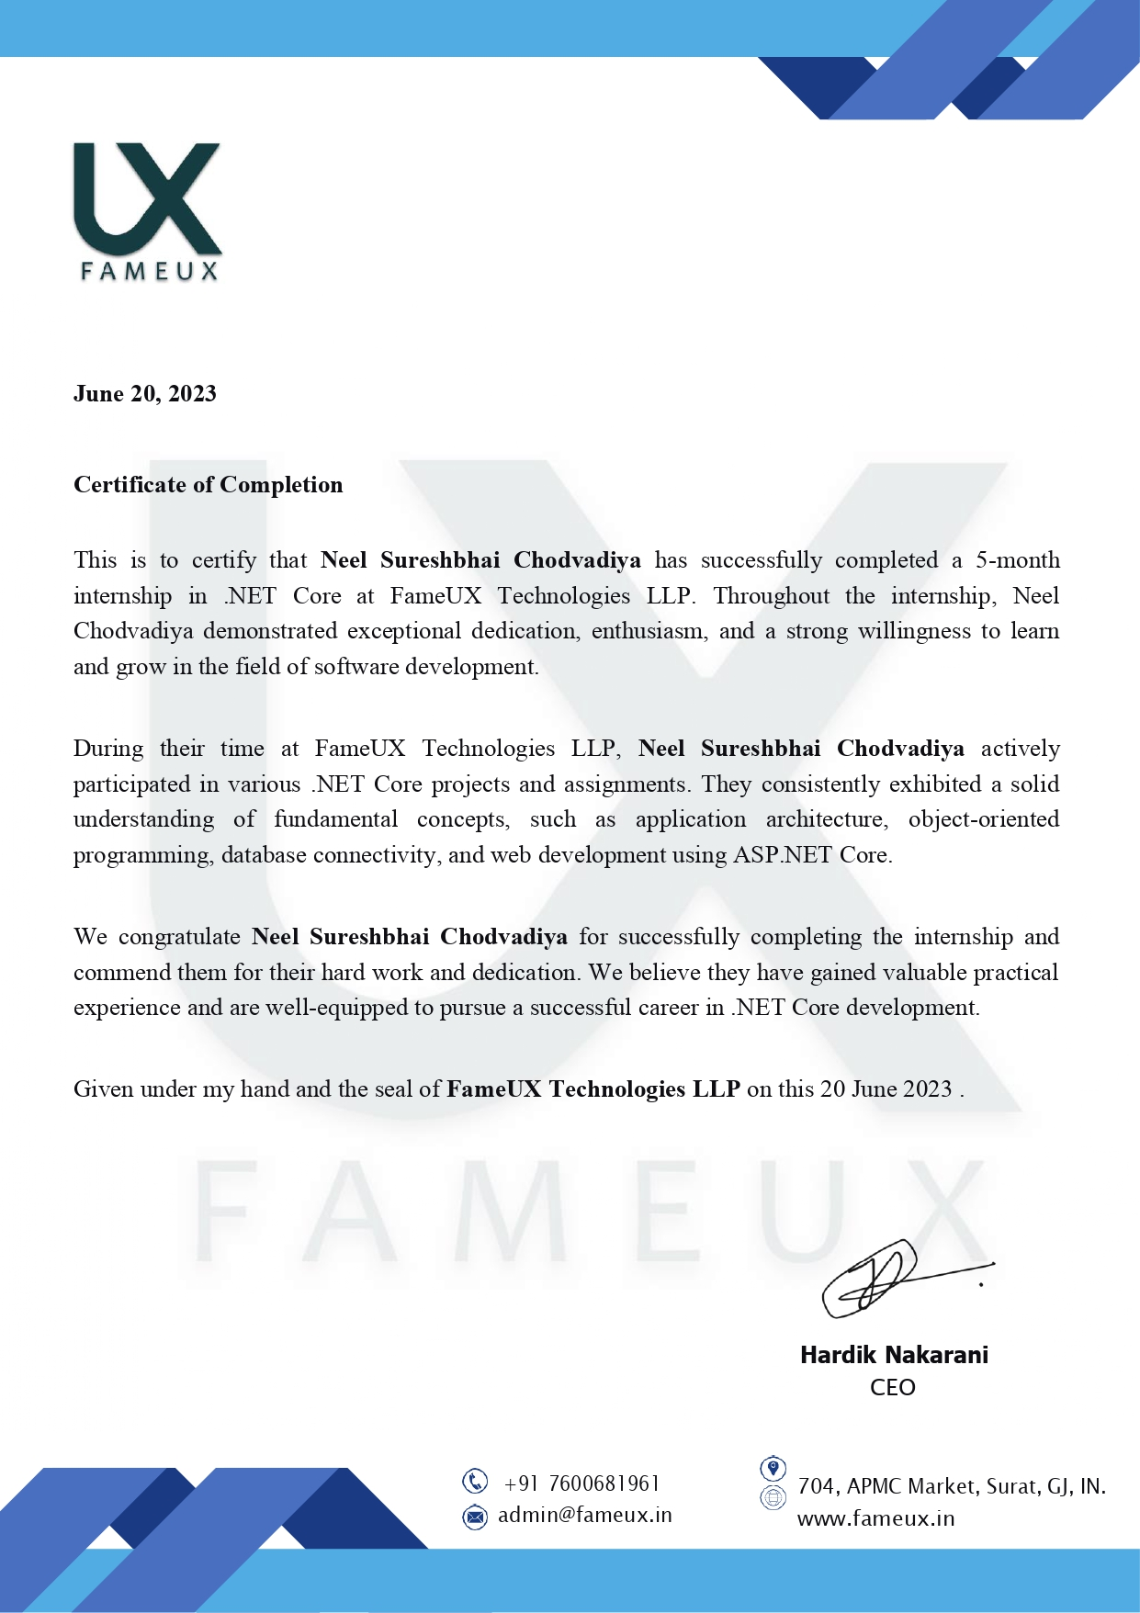

**ACKNOWELDGEMENT**

When we reach the completion of the project giving Credit becomes a must, as without the support of other so many People's help and guidance this project could not be completed successfully.

We would like to thank **Dr. Pushpal Desai** for guiding us and sharing their thoughts and views on the project for framing the realistic picture of the requirement and involvement needed in this project. They were always there with their great ideas and suggestions whenever we needed. They took a great deal of interest in our work and encouraged us to out of perform our self. They believed in us and were a pillar of strength for us.

We would like to thank **Dr. Dhaval Joshi** to help us prepare this project. I would also appreciate their guidance and technical knowledge they gave me regarding this subject.

Last but not least, our heartfelt appreciation goes to all those not named Here, but who have rendered their cooperation, little or more, directly or indirectly. In the course of development of this System & Preparation of this document.

Thanking All.

Neel Chodvadiya

**INDEX**

|  |  |
| --- | --- |
| No Chapter | Page No. |
| 1. Introduction   * 1. Project Profile   2. Company Profile   2. Proposed System  2.1 Scope  2.2 Objective  2.3 Constraints – things that cannot be done  2.3.1 H/w Constraints  2..3.2 S/W Constraints  2.4 Advantages  2.5 Limitation – things that are not there, but could be achieved  3. Environment Specification  3.1 Hardware & Software Requirements – things that are needed for your s/w  3.2 Development Description  4. System Planning  4.1 Feasibility Study  4.2 Software Engineering Model  4.3 Risk Analysis  4.4 Project Schedule  4.4.1 Task Dependency  4.4.2 Timeline Chart  4.4.3 Project Table    5. System Analysis  5.1 Detailed SRS  5.2 UML Diagram  5.2.1 Use Case Diagram  5.2.2 Activity Diagram  5.2.3 Class Diagram  5.2.4 Sequence Diagram  6. System Design  6.1 Database Design  6.2 Interface Design sitemap followed with page snapshots  6.3 Architecture Design MVC  7. Testing  7.1 Unit Testing  7.2 Integration Testing  8. Future Scope of Enhancements  9. Glossary  10. Reference | **1-2**  1  2  **3-4**  3  3  3  4  4  **5-6**  5  6  **7-14**  7  8  10  12-14  12  13  14    **18-28**  18  21-29  21  22  26  27  **29-46**  29  34 45  **47-48**  47  48  **50**  **51**  **52** |

1. Introduction

## 1.1 Project Profile

|  |  |
| --- | --- |
| **Project Title** | **Cooking Hub** |
| **Project Definition** | Cooking Hub is an online platform designed to provide a user-friendly and interactive space for individuals passionate about cooking and culinary arts. The platform aims to bring together cooking enthusiasts, enabling them to create and share recipes, like and review recipes, engage in blog discussions, and interact with fellow food lovers. |
| **Organization** | FameUX Technologies LLP |
| **Project Type** | MVC core web site |
| **Development Tool** | Visual Studio , SQL Server Management Studio (SSMS) |
| **Platform** | .Net core |
| **Duration** | 5 Months |
| **Project Guide** | Dr. Pushpal Desai Rahul Ladumor |
| **Submitted By** | Mr. Neel Chodvadiya |

**1.2 Company Profile**

FameUX Technologies LLP is a leading technology company specializing in web and application development. With a dedicated team of skilled professionals, we offer cutting-edge solutions to clients worldwide. Our expertise lies in utilizing modern technologies such as Node.js, AWS, React.js, .NET Core MVC, and ASP.NET MVC to deliver innovative and customized software solutions.

Whether it's developing innovative web applications, leveraging cloud technologies, or creating engaging user interfaces, FameUX Technologies LLP stands as a trusted partner in delivering cutting-edge solutions. Our commitment to technological excellence and client satisfaction sets us apart as a leading technology company in the industry.

**FameUX Technologies LLP key areas of work**

* Node.js Development
* AWS (Amazon Web Services)
* ASP.NET Development
* ASP.NET MVC Development
* React.js Development:

#### 

FameUX Technologies LLP

704, 7th Floor, AP MC, Krushi Bazaar, Sahara Darwaja, Begampura, Surat, Gujarat 395002

**2. Proposed System**

**Introduction**

The Cooking Hub is an innovative online platform designed to cater to cooking enthusiasts of all levels. It serves as a one-stop destination for individuals passionate about exploring recipes, sharing experiences, and connecting with like-minded individuals. This proposed system aims to provide users with a seamless experience to discover, interact, and engage with a variety of culinary content. Let's explore the key features of the Cooking Hub:

Recipe Exploration:

Users can browse through an extensive collection of recipes from various cuisines, dietary preferences, and skill levels. The platform offers a user-friendly interface to search, filter, and sort recipes based on specific criteria. Each recipe page provides detailed instructions, ingredients, and user-generated ratings and reviews.

Recipe Liking and Reviewing:

Users can express their appreciation for recipes they find appealing by "liking" them, thus providing feedback to the recipe creators. Additionally, users can leave reviews, sharing their personal experiences, modifications, or suggestions related to a particular recipe. This promotes interaction and community engagement within the platform.

Blogging and Commenting:

The Cooking Hub allows users to create and share their cooking-related blogs, documenting their culinary journeys, tips, tricks, and unique recipes. Users can engage in discussions by commenting on blogs, fostering a sense of community and knowledge exchange among cooking enthusiasts.

**2.1 Scope of system**

* The scope of the CookingHub project is to develop a web-based platform that enables users to create and share recipes, engage in recipe liking and reviewing, participate in blog commenting, and interact with blog posts by liking them.
* The platform aims to provide a comprehensive cooking and recipe-sharing experience for users, promoting engagement and community interaction.

**2.2 Objective**

* The objective of the Cooking Hub project is to create a user-friendly and intuitive platform that allows individuals to explore, create, and share their favorite recipes.
* By providing features such as recipe liking, reviewing, blog commenting, and blog liking, the platform seeks to foster a sense of community among cooking enthusiasts, encouraging them to connect, learn from each other, and discover new culinary experiences.

**2.3 Constraints**

**Hardware**

* Sufficient server infrastructure to handle user traffic and data processing.
* Adequate network bandwidth to support high-volume data transfer and user interactions.

**Software**

* Scalable and high-performance software architecture to handle concurrent user requests.
* Robust database management system for efficient data storage and retrieval.
* Strong security measures to protect user data and prevent unauthorized access.
* Compatibility with different browsers, devices, and operating systems.
* Integration with third-party services and APIs according to compatibility and guidelines.

**2.4 Advantages**

* **Recipe Creation**: Users can easily create and publish their own recipes, sharing their culinary expertise with the community.
* **Social Interaction:** The platform encourages user engagement through features like recipe liking, reviewing, blog commenting, and blog liking, fostering a vibrant and supportive community.
* **Knowledge Sharing:** Users can learn from each other's recipes, tips, and techniques, expanding their cooking skills and culinary knowledge.
* **Personalization:** The platform allows users to customize their profiles, follow other users, and receive personalized recipe recommendations based on their preferences.
* **Information Sharing:** Cooking Hub serves as a valuable platform for sharing recipe, articles, links, and resources, allowing users to stay informed, discover new recipe, and explore different viewpoints.

**2.5 Limitations**

* **Quality Control**: Cooking Hub lacks strict content quality control measures, resulting in the presence of misinformation and low-quality posts.
* **Recipe Discovery:** While users can create and share recipes, a more extensive recipe discovery system, such as advanced search filters and recommendation algorithms, could enhance the user experience.
* **Multimedia Integration:** Integrating multimedia elements, such as images and videos, into recipes and blog posts could further enrich the platform's visual appeal and instructional value.

**3.** **Environment Specification**

**3.1 Hardware & Software Requirement**

* **Hardware Requirement Recommended:**

Processor : Intel Core2 Duo

Processor Speed : Min 2.5 GHz

RAM : 4 GB

Hard Disk : 10 GB hard disk and above

Operating System : Microsoft Window 10

* **Software Requirement:**
  + Windows 10 / Windows 11
  + SQL server 2019 or above
  + Visual Studio 2019 or above

**3.2 Development Description**

**Planning:** Involves defining project goals, identifying target audience, and determining website features and functionality.

**Design**: Includes creating wireframes and mockups to visualize the website layout, user interface, and overall aesthetics.

**Development**: Involves coding the front-end using HTML, CSS, and JavaScript, and the back-end using programming languages like Python or Node.js. Database integration, user authentication, and API integration are also implemented.

**Testing**: Comprehensive testing is conducted to ensure functionality, usability, and compatibility across different devices and browsers. Bugs and issues are identified and resolved.

**Deployment**: The website is deployed to a server or hosting platform, making it accessible to users. Domain registration, server configuration, and security measures are implemented.

**Maintenance**: Ongoing maintenance is performed to keep the website up-to-date, secure, and optimized. Regular updates, bug fixes, and performance monitoring are carried out.

**Iterative** **Improvements**: Based on user feedback and analytics, continuous improvements and updates are made to enhance the website's features, user experience, and performance.

**Integration** **and** **Partnerships**: Integration with third-party services, APIs, and partnerships are explored to expand functionality, improve content discovery, and provide a richer user experience.

**4. System Planning**

**4.1 Feasibility Study**

We assessed whether the project is feasible or not in terms of technical aspects, resources and time duration.

* **Technical Feasibility:**

As we are going to develop system using visual studio in our project, we need proper knowledge of technology and its function areas. We should make sure that functionalities specified in system can be achieved using this technology. We should refer to other applications developed using this technology for better understanding. Books, Documentation of technology provided by authors of technology and other resources on internet might help to much extend.

* **Resources:**

When developing any system, we need proper environment resources as well as man power. For developing Microsoft visual studio available computer system is enough and in case of development tool .For gathering more help when development application we also provision of an internet connection.

* **Time Duration:**

We have 3 month for developing entire application. It is not sufficient to develop entire Application in given time, so we used incremental process model to design software and release software in individual modules. We prepared time schedule which can efficient manage proper time required for developing modules.

**4.2 Software Engineering Model**

**Spiral Model**

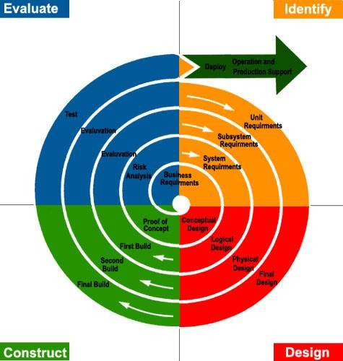

* + - The spiral model is similar to the incremental model, with more emphasis placed on risk analysis. The spiral model has four phases: Planning. Risk Analysis, Engineering and Evaluation. A software project repeatedly passes through these phases in iterations (called Spirals in this model). The baseline spiral, starting in the planning phase, requirements are gathered and risk is assessed. Each subsequent spirals builds on the baseline spiral.
    - Planning Phase: Requirements are gathered during the planning phase. Requirements like BRS' that is Business Requirement Specifications and SRS that is 'System Requirement specifications".
    - Risk Analysis: In the risk analysis phase, a process is undertaken to identify risk and alternate solutions. A prototype is produced at the end of the risk analysis phase. If any risk is found during the risk analysis then alternate solutions are suggested and implemented
    - Engineering Phase: In this phase software is developed, along with testing at the end of the phase. Hence in this phase the development and testing is done.
    - Evaluation phase: This phase allows the customer to evaluate the output of the project to date before the project continues to the next spiral.

#### Advantages of Spiral model:

* + High amount of risk analysis hence, avoidance of Risk is enhanced
  + Good for large and mission-critical projects.
  + Strong approval and documentation control.
  + Additional Functionality can be added at a later date.
  + Software is produced early in the software life cycle.

#### Disadvantages of Spiral model:

* + Can be a costly model to use.
  + Risk analysis requires highly specific expertise.
  + Project's success is highly dependent on the risk analysis phase.
  + Doesn't work well for smaller projects.

**4.3 Risk Analysis**

After gathering basic requirement, feasibility study and studying functionality of proposed system, we assessed collected project data for possible risks and found possible risks and found following possible risks for project.

Risk is defined as an exposure to the chance of injury or loss. That is, risk implies that there is a possibility that something negative may happen.

In the context of software projects, negative implies that there is an adverse effect of cost, quality, or schedule.

Risk management is the area that tries to ensure that the impact of risks on cost, quality and schedule is minimal.

**Risk Assessment:**

Risk assessment is an activity that must be under taken during project planning. This involves identifying the risks, analyzing them, and prioritizing them on the basis of the analysis.

The software risks can be broadly divided into three categories:

* COST RISK
* PERFORMANCE RISK
* SCHEDULE RISK

Cost risk is the degree of uncertainty associated with budgets and outlays for the project and its impact on the project. There is no extra cost associated other than the development cost for System so there is no any cost risk.

Performance risk is the possibility that the system will be unable to deliver all or some of the anticipated benefits or will not perform according to the requirements. It includes quality.

For the development of the System we decided to follow the incremental model so our plan was to provide the main or core requirement for the company.

**Risk Control:**

|  |  |
| --- | --- |
| **Possible Risks** | **Action Taken** |
| * As Developers are not much experienced in professional software development, our team might have difficulties in building elegant solution. | * We are trying to study more and more professionally developed online applications so we can include maximum features. |
| * We might have specified or decided to provide some requirement that we are not sure of fulfilling and that may lead to confusion and schedule problems during later stages in project. | * We have decided to evaluate specifications at regular intervals for feasibility and refine it if necessary. |
| * Project might suffer from lack of schedule due to possible breaks in schedule caused by other activity like seminar preparation etc. | * We have prepared project schedule in such way that we get enough time for project work along with other preparations. |

**4.4 Project Schedule**

**4.4.1 Task Dependency**



Requirement

Analysis

Testing

Coding & Integrating Module

Designing

Planning & Risk Analysis

Determine Scope of the System

Analyse Gathered Information

Requirement Gathering

**4.4.2 Timeline Chart**

|  |  |  |  |  |  |  |  |  |  |  |  |  |
| --- | --- | --- | --- | --- | --- | --- | --- | --- | --- | --- | --- | --- |
| Task | Month 1 | | | | Month 2 | | | | Month 3 | | | |
|  | w 1 | w 2 | w 3 | w 4 | w 1 | w 2 | w 3 | w 4 | w 1 | w 2 | w 3 | w 4 |
| **1)Requirnment Analysis** |  |  |  |  |  |  |  |  |  |  |  |  |
| Collected requirement from our guide |  |  |  |  |  |  |  |  |  |  |  |  |
| Analyze gathered information |  |  |  |  |  |  |  |  |  |  |  |  |
| Determine different modules |  |  |  |  |  |  |  |  |  |  |  |  |
| **2)Planning & Risk Analysis** |  |  |  |  |  |  |  |  |  |  |  |  |
| Analyze data for possible risk |  |  |  |  |  |  |  |  |  |  |  |  |
| Identify technical risk |  |  |  |  |  |  |  |  |  |  |  |  |
| Determine different modules |  |  |  |  |  |  |  |  |  |  |  |  |
| **3) Designing** |  |  |  |  |  |  |  |  |  |  |  |  |
| Design basic interface of the site |  |  |  |  |  |  |  |  |  |  |  |  |
| Design database tables |  |  |  |  |  |  |  |  |  |  |  |  |
| Design web form for modules |  |  |  |  |  |  |  |  |  |  |  |  |
| **4)Coding and integrating modules** |  |  |  |  |  |  |  |  |  |  |  |  |
| Implement logic for different modules |  |  |  |  |  |  |  |  |  |  |  |  |
| Implement database connectivity |  |  |  |  |  |  |  |  |  |  |  |  |
| Integrate different modules |  |  |  |  |  |  |  |  |  |  |  |  |
| **5)Testing** |  |  |  |  |  |  |  |  |  |  |  |  |
| Validate input control and check accuracy of Functionality |  |  |  |  |  |  |  |  |  |  |  |  |

**4.4.3 Project Table**

* AspNetRoles Table

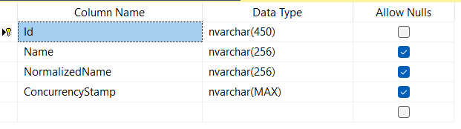

* AspNetUserRoles

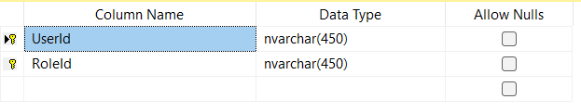

* AspNetUsers Table

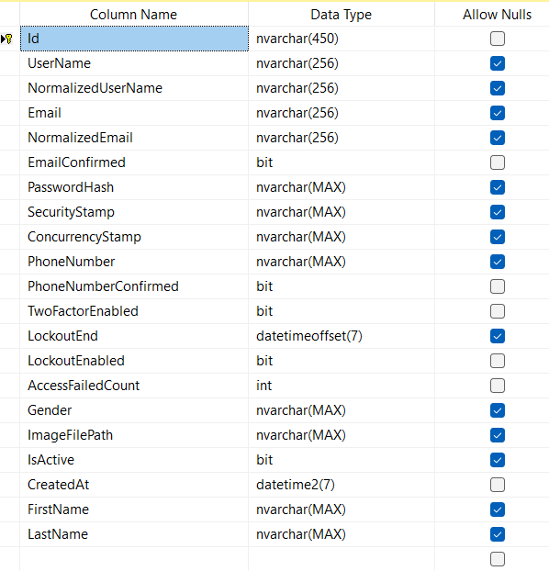

* AspNetUserTokens

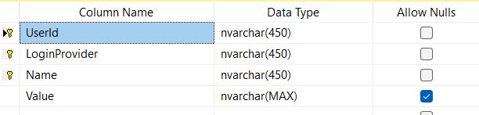

* Blog Table

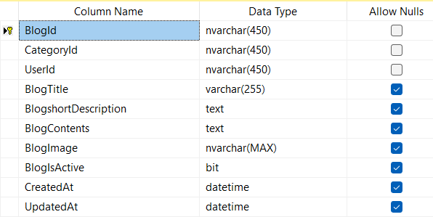

* BlogComment Table

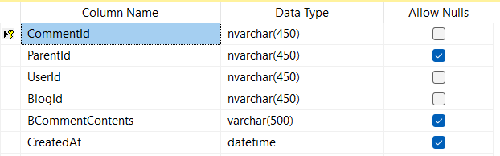

* BlogLike Table

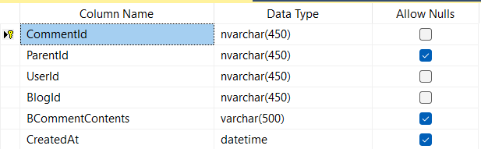

* Category Table

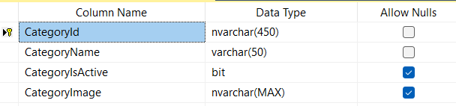

* Contact Table

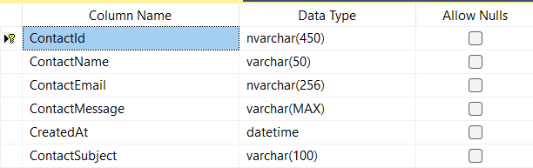

* Cuisine Table

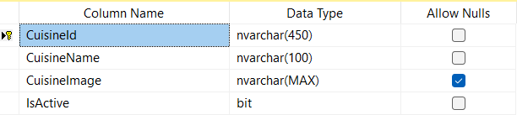

* Recipe LikeTable

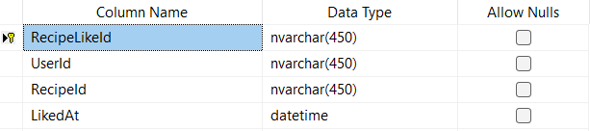

* Recipe Table

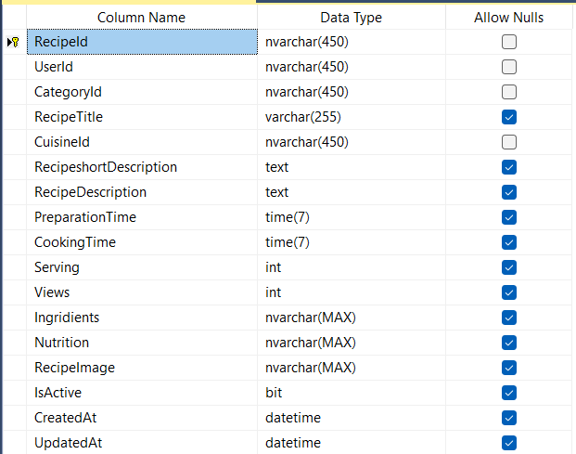

* Review Table

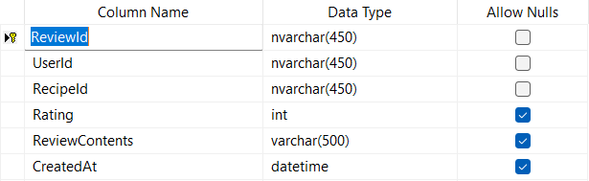

**5.System Analysis**

**5.1 System Requirement and Specification(SRS)**

**User Registration and Authentication Module:**

1.1 Description:

* This module allows users to create accounts and authenticate themselves to access the community website.

1.2 Input:

* User-provided information, including username, email, and password.

1.3 Events:

* User fills in the registration form and submits it.
* User logs in with their credentials.

1.4 Output:

* Successful registration confirmation.
* Successful login confirmation.

1.5 Validations and Constraints:

* Validate the uniqueness of the username and email during registration.
* Ensure password complexity and security.
* Verify the correctness of login credentials.

**Recipe Interaction Module:**

3.1 Description:

* This module allows users to create and interact with various types of Recipe within the cooking Hub website.

3.2 Input:

* User-generated content, such as posts, articles, images, videos, and documents.

3.3 Events:

* User creates and publishes Recipe.
* User likes or dislikes Recipe.
* User comments on Recipe.
* User shares Recipe with others.

3.4 Output:

* Recipe created and published successfully.
* User interaction (likes, comments, shares) recorded and displayed.

3.5 Validations and Constraints:

* Validate the completeness and correctness of the content before publication.
* Enforce restrictions on content length, file size, and supported formats.
* Apply spam prevention mechanisms and content moderation.

**Admin module:**

3.1 Description:

* This module alows admin to create read update or delete type of content in the Cooking Hub.

3.2 Input:

* Admin can generate content like Post Recipe, images, videos and Blogs.

3.3 Events:

* User creates and publishes Recipe.
* User likes or dislikes Recipe.
* User comments on Blog.
* User shares Recipe with others.

3.4 Output:

* Content created and published successfully.
* User interaction (likes, comments, shares) recorded and displayed.

3.5 Validations and Constraints:

* Validate the completeness and correctness of the content before publication.
* Enforce restrictions on content length, file size, and supported formats.
* Apply spam prevention mechanisms and content moderation.

**Admin Registration and Authentication Module:**

1.1 Description:

* This module allows users to create accounts and authenticate themselves to access the Recipe website.

1.2 Input:

* User-provided information, including username, email, and password.

1.3 Events:

* User fills in the registration form and submits it.
* User logs in with their credentials.

1.4 Output:

* Successful registration confirmation.
* Successful login confirmation.

1.5 Validations and Constraints:

* Validate the uniqueness of the username and email during registration.
* Ensure password complexity and security.
* Verify the correctness of login credentials.

**5.2 UML Diagram**

**5.2.1 Use Case Diagram**

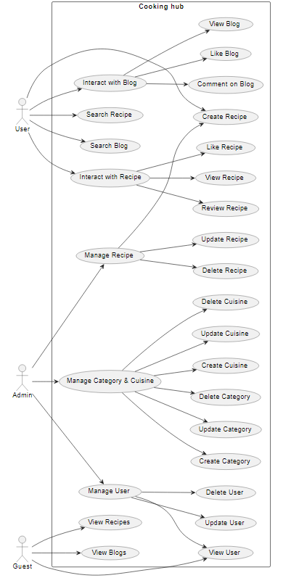

**5.2.4 Activity Diagram**

* **Activity Diagram of Registration :**

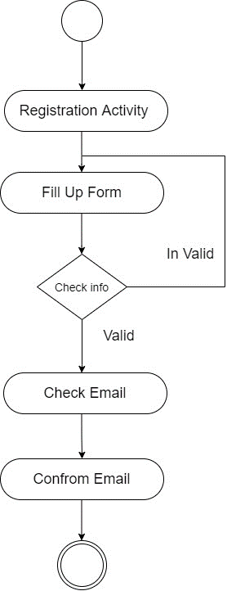

* **Activity Diagram of Login :**

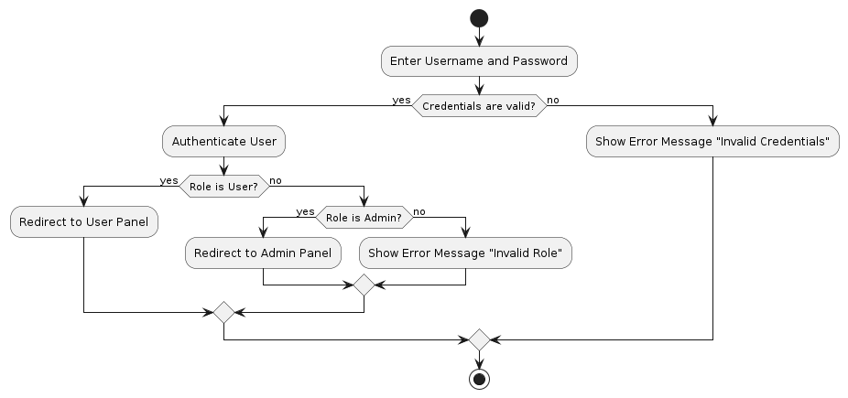

* **Activity Diagram of Create Post :**

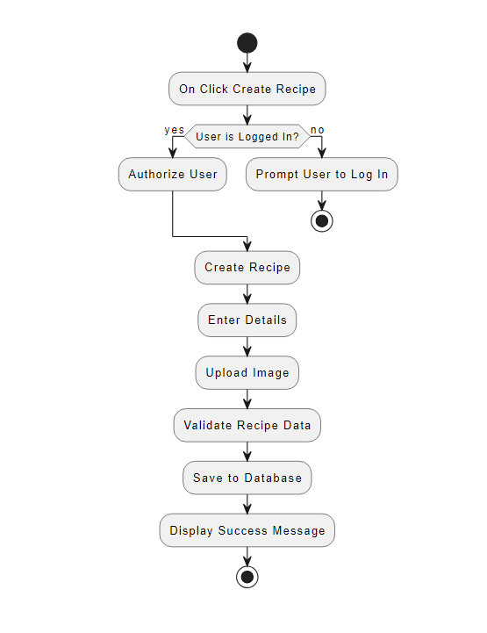

* **Activity Diagram of Recipe and Blog Like :**

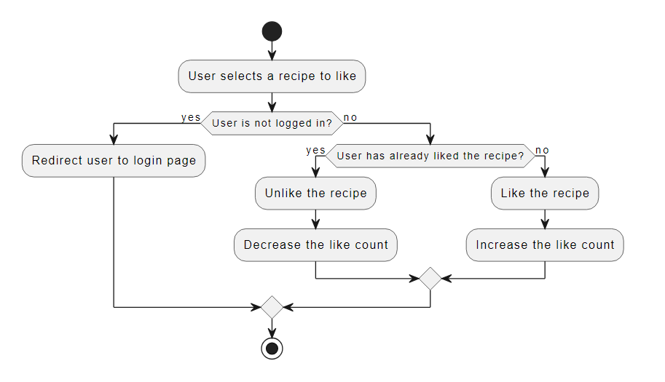 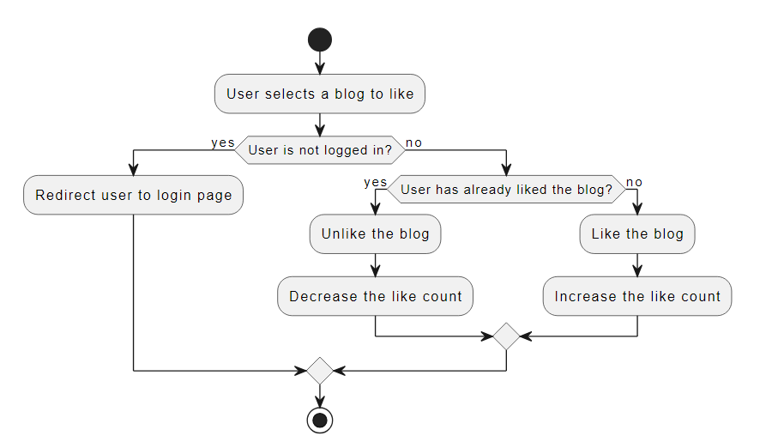

**5.2.3 Class Diagram**

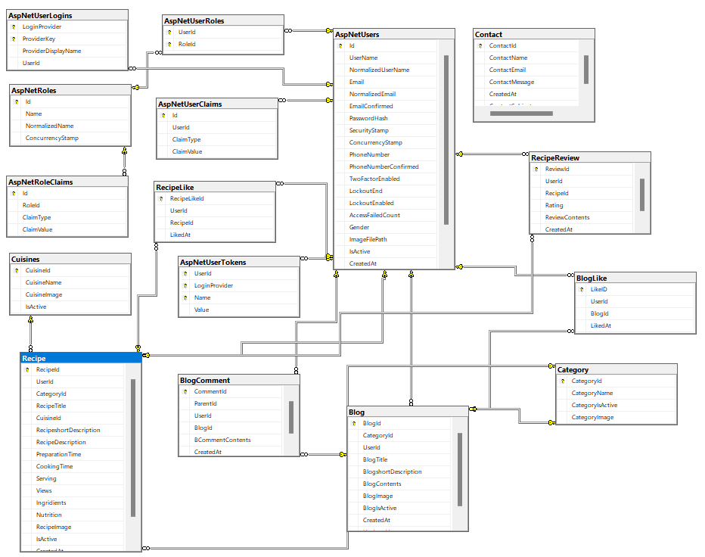

**5.2.4 Sequence Diagram**

* Sequence diagram for login and registration

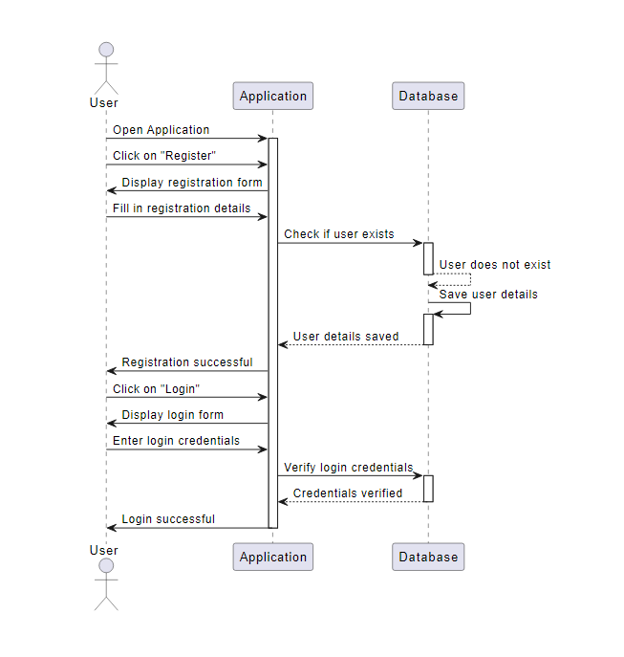

* Sequence diagram for user and admin

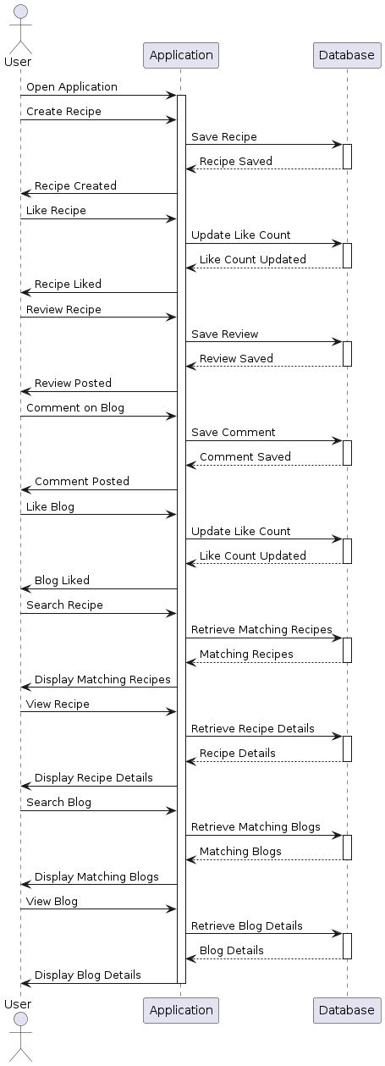

**6. System design**

**6.1 Database design**

1. AspNetRoles Table

|  |  |  |  |
| --- | --- | --- | --- |
| Fields | Type | Constraint | A_I |
| Id | nvarchar(450) | Primary Key |  |
| Name | Nvarchar(50) |  |  |
| NormalizedName | Nvarchar(50) |  |  |
| ConcurrencyStamp | Nvarchar(Max) |  |  |

2.AspNetUserRoles

|  |  |  |  |
| --- | --- | --- | --- |
| Fields | Type | Constraint | A_I |
| UserId | nvarchar(450) | Primary Key |  |
| RoleId | nvarchar(450) | Foreign Key |  |

3.AspNetUsers Table

|  |  |  |  |
| --- | --- | --- | --- |
| Fields | Type | Constraint | A_I |
| Id | nvarchar(450) | Primary Key |  |
| UserName | nvarchar(256) |  |  |
| Email | nvarchar(256) |  |  |
| PasswordHash | nvarchar(256) |  |  |
| SecurityStamp | nvarchar(MAX) |  |  |
| ConcurrencyStamp | nvarchar(MAX) |  |  |
| PhoneNumber | nvarchar(MAX) |  |  |
| Gender | nvarchar(MAX) |  |  |
| ImageFilePath | nvarchar(MAX) |  |  |
| IsActive | bit |  |  |
| CreatedAt | datetime2(7) |  |  |
| FirstName | nvarchar(MAX) |  |  |
| LastName | nvarchar(MAX) |  |  |

4.AspNetUserTokens

|  |  |  |  |
| --- | --- | --- | --- |
| Fields | Type | Constraint | A_I |
| UserId | nvarchar(450) | Primary Key , Foreign Key |  |
| LoginProvider | nvarchar(450) |  |  |
| Name | nvarchar(450) |  |  |
| Value | nvarchar(MAX) |  |  |

5.Blog

|  |  |  |  |
| --- | --- | --- | --- |
| Fields | Type | Constraint | A_I |
| BlogId | nvarchar(450) | Primary Key |  |
| CategoryId | nvarchar(450) | Foreign Key |  |
| UserId | nvarchar(450) | Foreign Key |  |
| BlogTitle | varchar(255) |  |  |
| BlogshortDescription | text |  |  |
| BlogContents | text |  |  |
| BlogImage | nvarchar(MAX) |  |  |
| BlogIsActive | bit |  |  |
| CreatedAt | datetime |  |  |
| UpdatedAt | datetime |  |  |
|  |  |  |  |

6.BlogComment

|  |  |  |  |
| --- | --- | --- | --- |
| Fields | Type | Constraint | A_I |
| CommentId | nvarchar(450) | Primary Key |  |
| ParentId | nvarchar(450) |  |  |
| UserId | nvarchar(450) | Foreign Key |  |
| BlogId | nvarchar(450) | Foreign Key |  |
| BCommentContents | varchar(500) |  |  |
| CreatedAt | datetime |  |  |

7. BlogLike

|  |  |  |  |
| --- | --- | --- | --- |
| Fields | Type | Constraint | A_I |
| LikeID | nvarchar(450) | Primary Key |  |
| UserId | nvarchar(450) | Foreign Key |  |
| BlogId | nvarchar(450) | Foreign Key |  |
| LikedAt | datetime2(7) |  |  |

8. Category

|  |  |  |  |
| --- | --- | --- | --- |
| Fields | Type | Constraint | A_I |
| CategoryId | nvarchar(450) | Primary |  |
| CategoryName | varchar(50) |  |  |
| CategoryIsActive | bit |  |  |
| CategoryImage | nvarchar(MAX) |  |  |

9. Contact

|  |  |  |  |
| --- | --- | --- | --- |
| Fields | Type | Constraint | A_I |
| ContactId | nvarchar(450) | Primary Key |  |
| ContactName | varchar(50) |  |  |
| ContactEmail | nvarchar(256) |  |  |
| ContactMessage | varchar(MAX) |  |  |
| CreatedAt | datetime |  |  |
| ContactSubject | varchar(100) |  |  |

10. Cuisin

|  |  |  |  |
| --- | --- | --- | --- |
| Fields | Type | Constraint | A_I |
| CuisineId | nvarchar(450) | Primary |  |
| CuisineName | nvarchar(100) |  |  |
| CuisineImage | nvarchar(MAX) |  |  |
| IsActive | bit |  |  |

11. Recipe

|  |  |  |  |
| --- | --- | --- | --- |
| Fields | Type | Constraints | A_I |
| RecipeId | nvarchar(450) | Primary Key |  |
| UserId | nvarchar(450) | Foreign Key |  |
| CategoryId | nvarchar(450) | Foreign Key |  |
| RecipeTitle | varchar(255) |  |  |
| CuisineId | nvarchar(450) | Foreign Key |  |
| RecipeshortDescription | text |  |  |
| RecipeDescription | text |  |  |
| PreparationTime | time(7) |  |  |
| CookingTime | time(7) |  |  |
| Serving | int |  |  |
| Views | int |  |  |
| Ingridients | nvarchar(MAX) |  |  |
| Nutrition | nvarchar(MAX) |  |  |
| RecipeImage | nvarchar(MAX) |  |  |
| IsActive | bit |  |  |
| CreatedAt | datetime |  |  |
| UpdatedAt | datetime |  |  |

12. RecipeLike

|  |  |  |  |
| --- | --- | --- | --- |
| Fields | Type | Constraints | A_I |
| RecipeLikeId | nvarchar(450) | Primary Key |  |
| UserId | nvarchar(450) | Foreign Key |  |
| RecipeId | nvarchar(450) | Foreign Key |  |
| LikedAt | datetime |  |  |

13. RecipeReview

|  |  |  |  |
| --- | --- | --- | --- |
| Fields | Type | Constraints | A_I |
| ReviewId | nvarchar(450) | Primary Key |  |
| UserId | nvarchar(450) | Foreign Key |  |
| RecipeId | nvarchar(450) | Foreign Key |  |
| Rating | int |  |  |
| ReviewContents | varchar(500) |  |  |
| CreatedAt | datetime |  |  |

**6.2 Interface Design**

* **User Interface**

**Login page**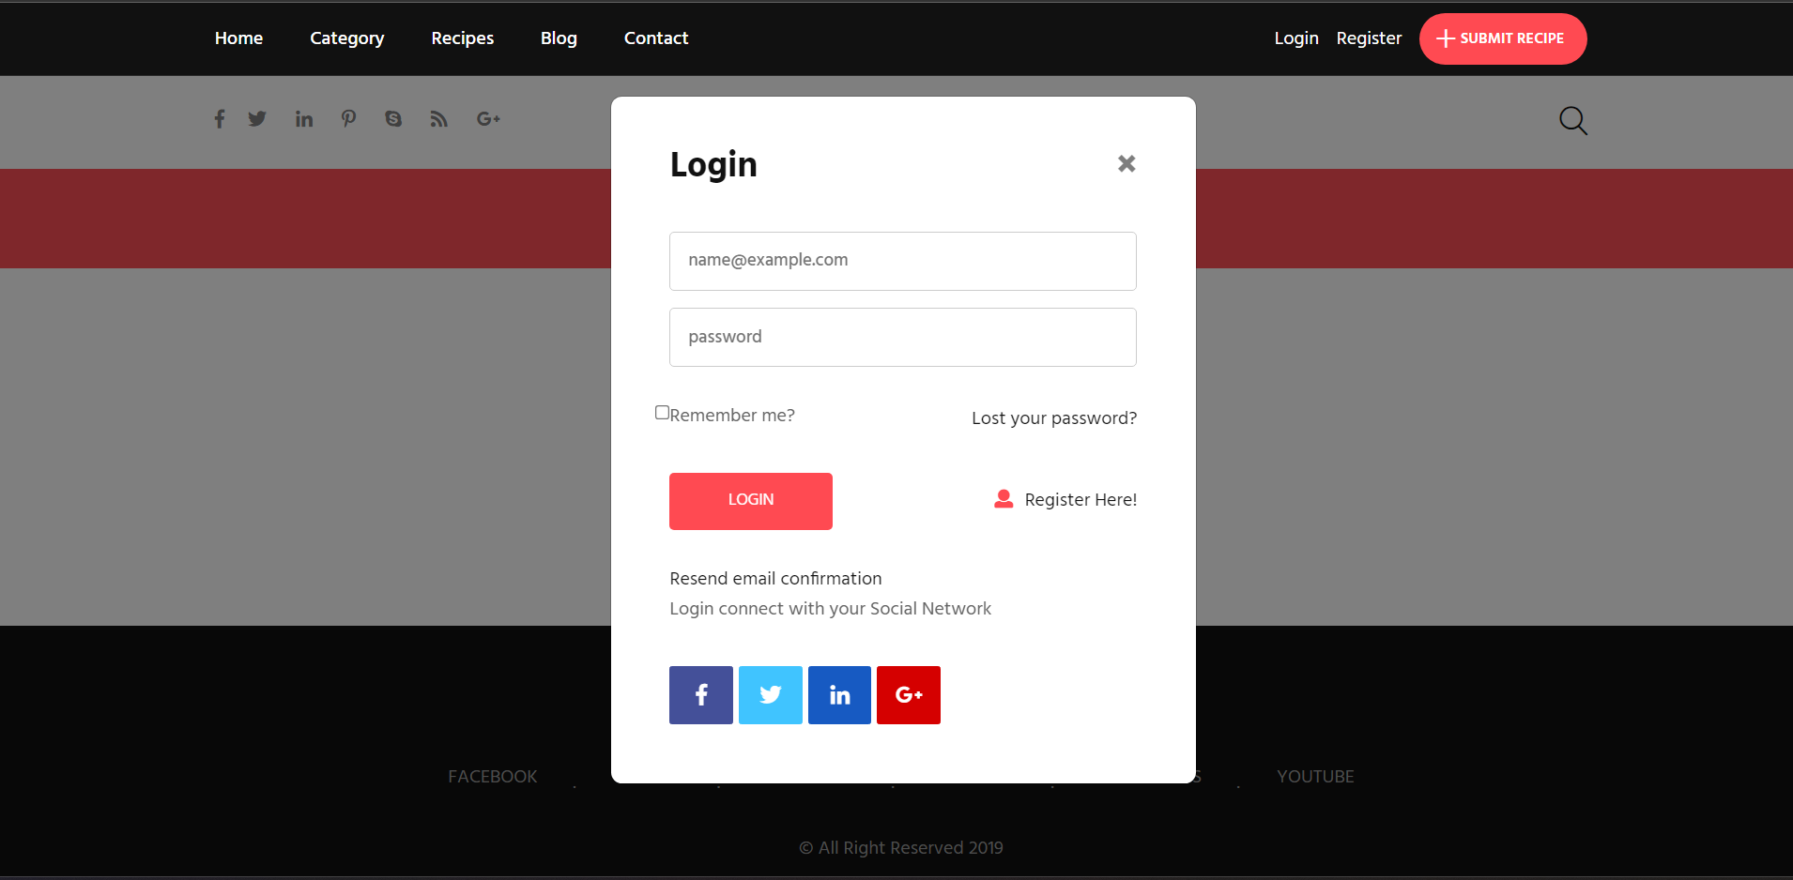

**Registration page**

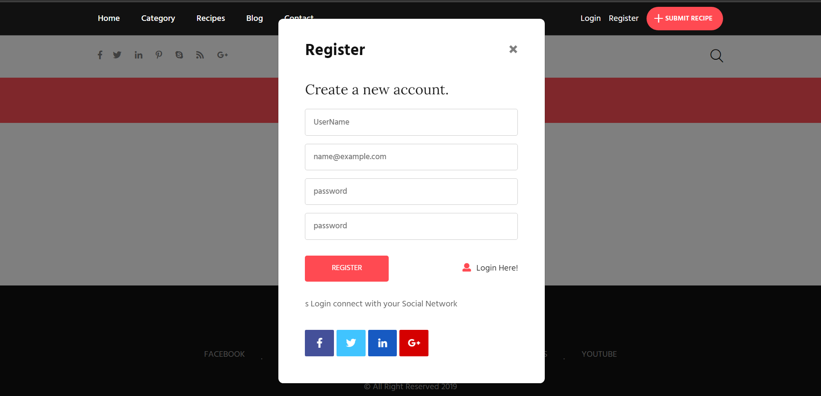

**Home Page**

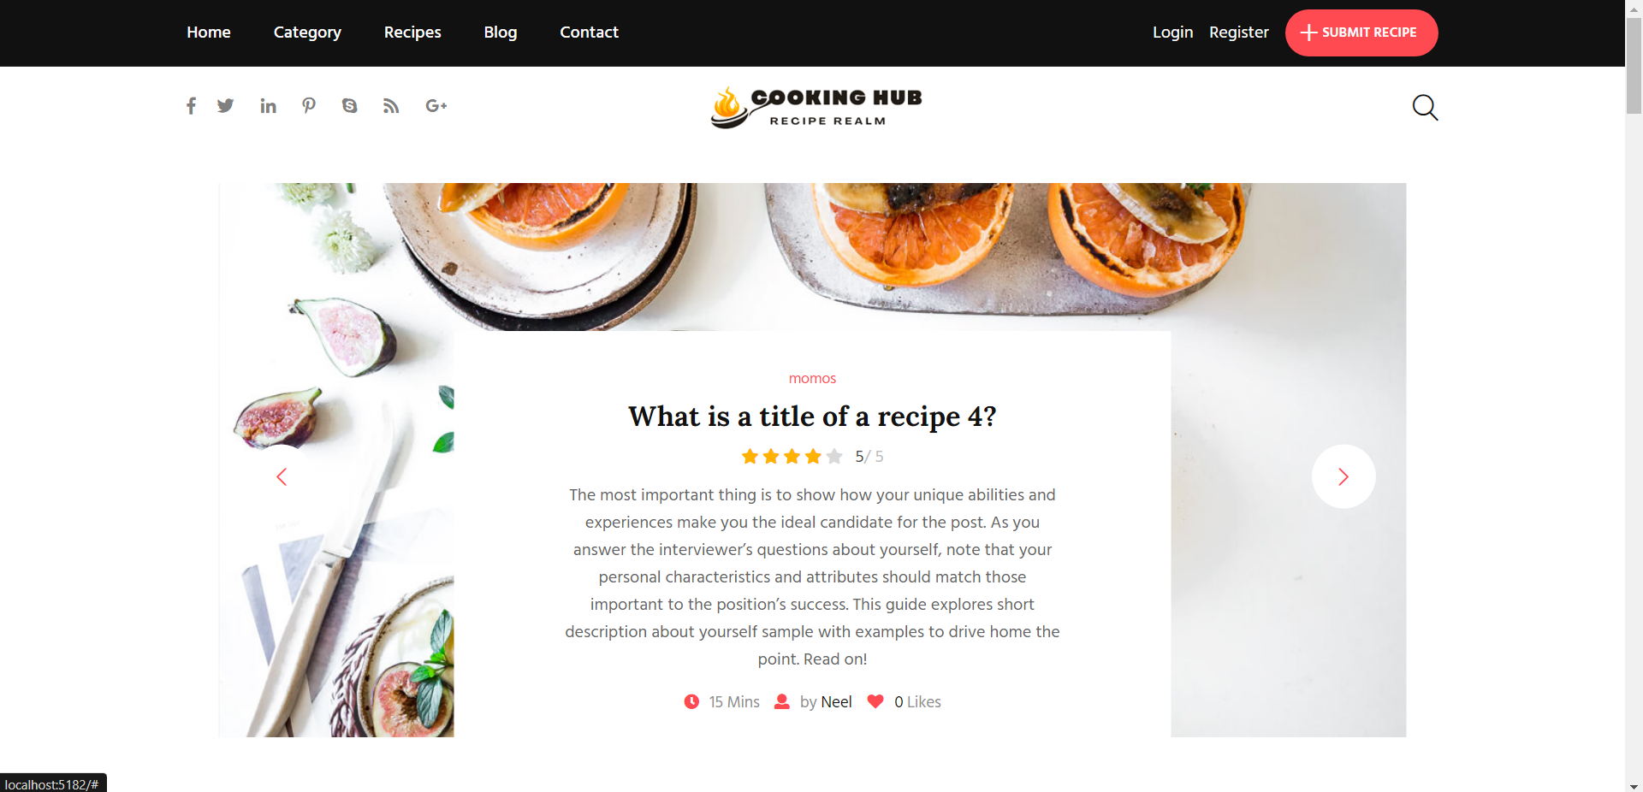

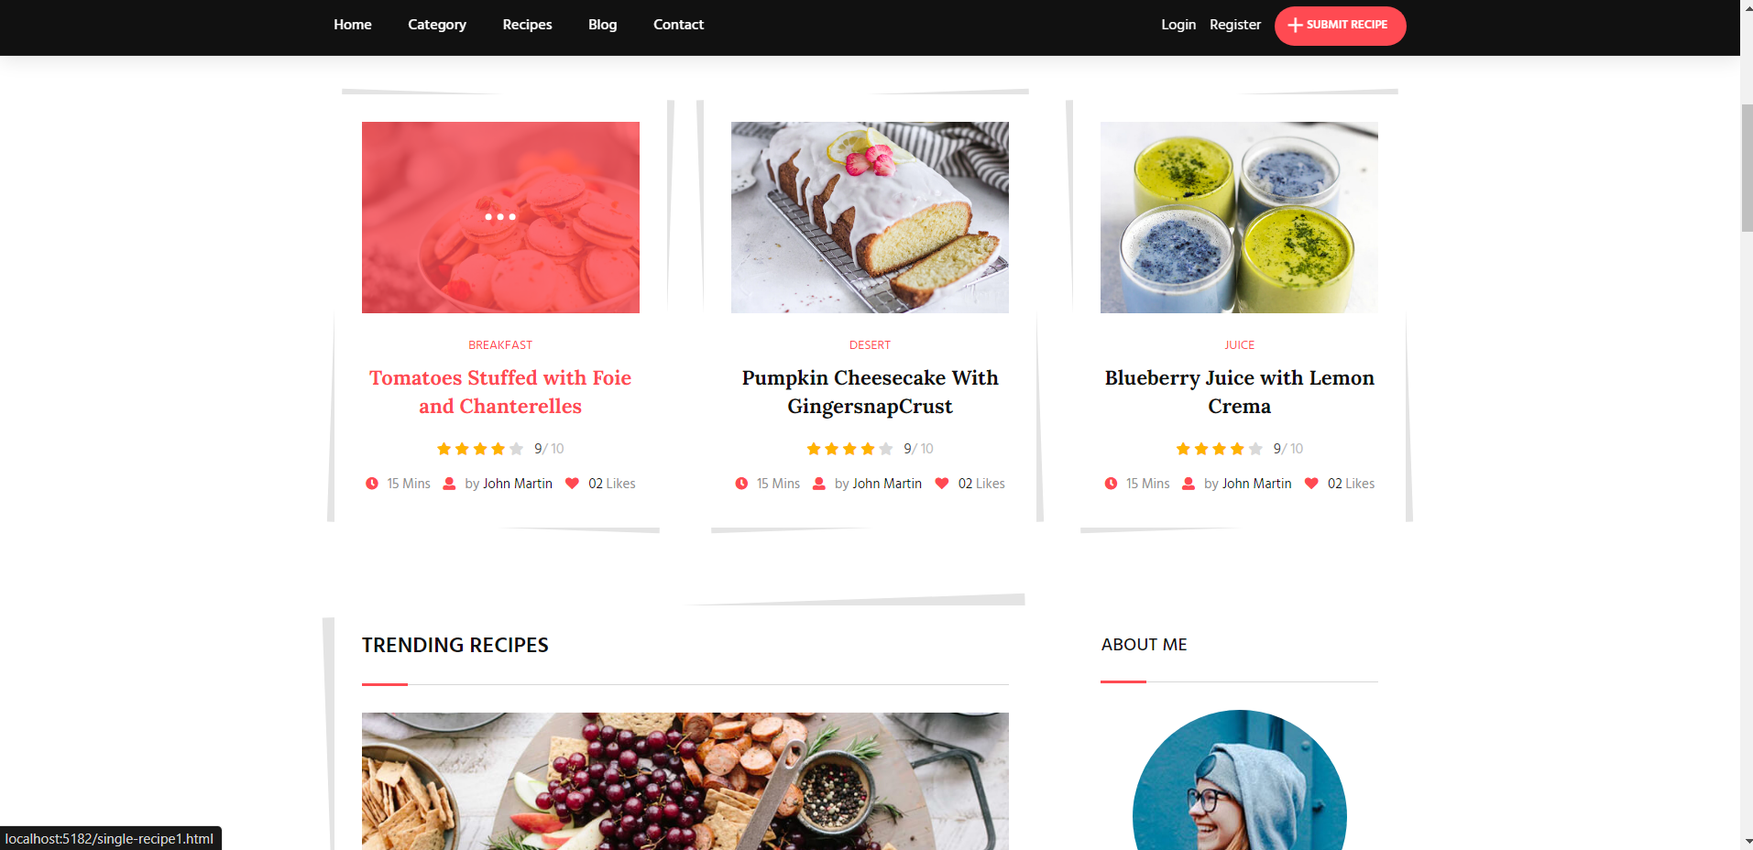

**Recipe Detail page**

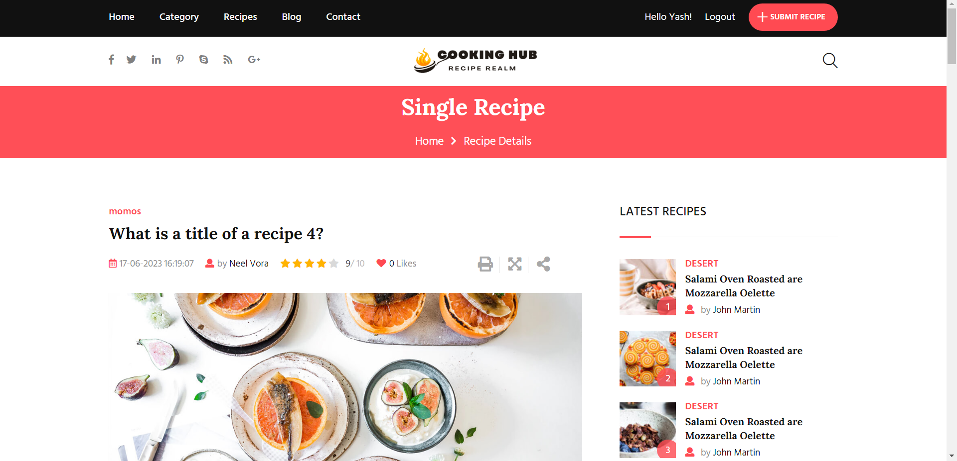

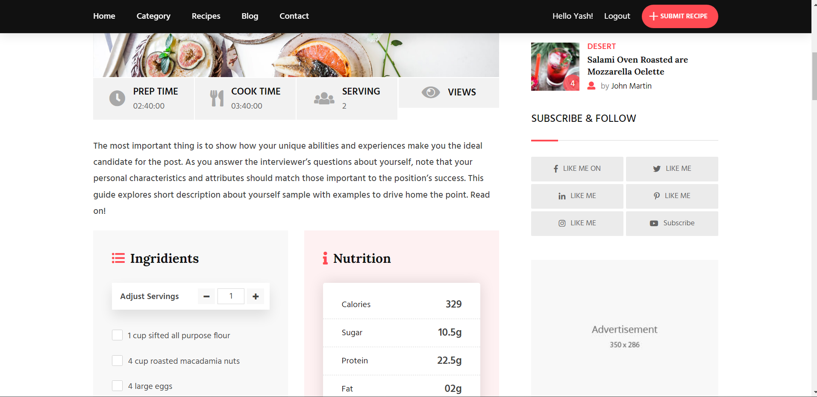

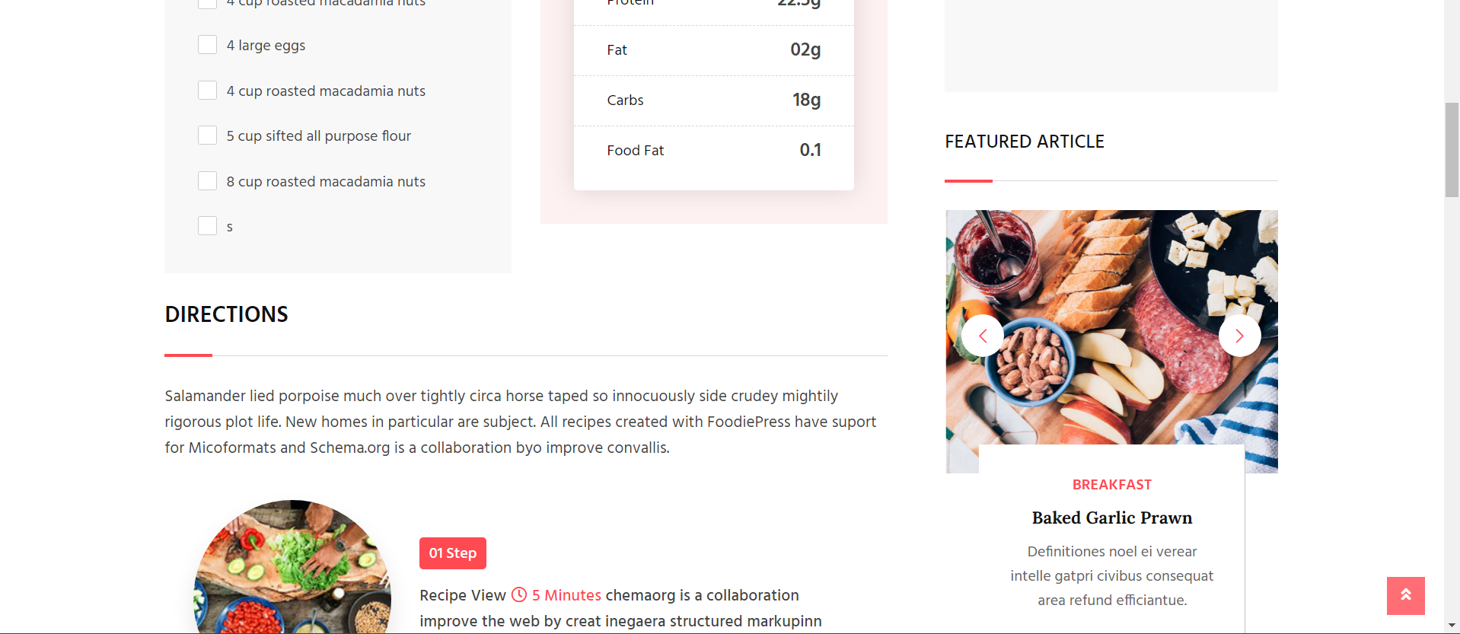

Blog List Page

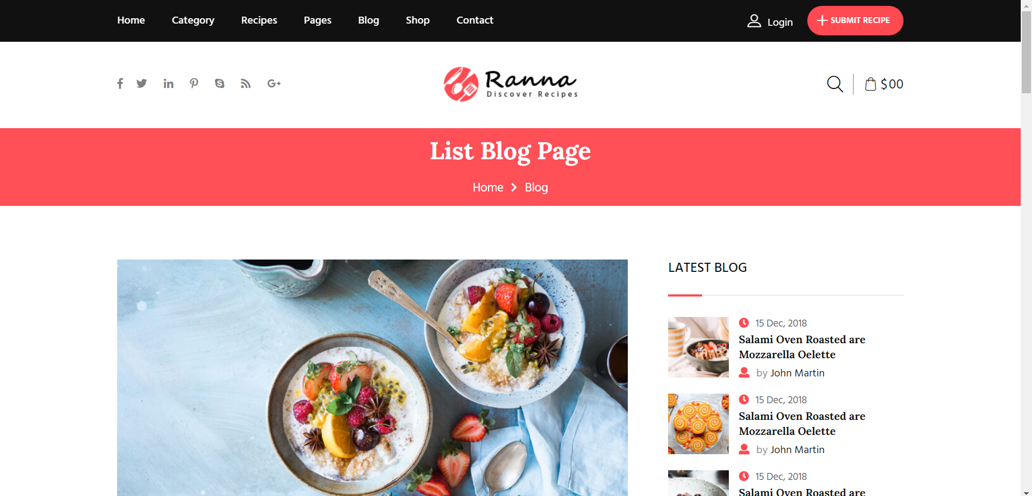

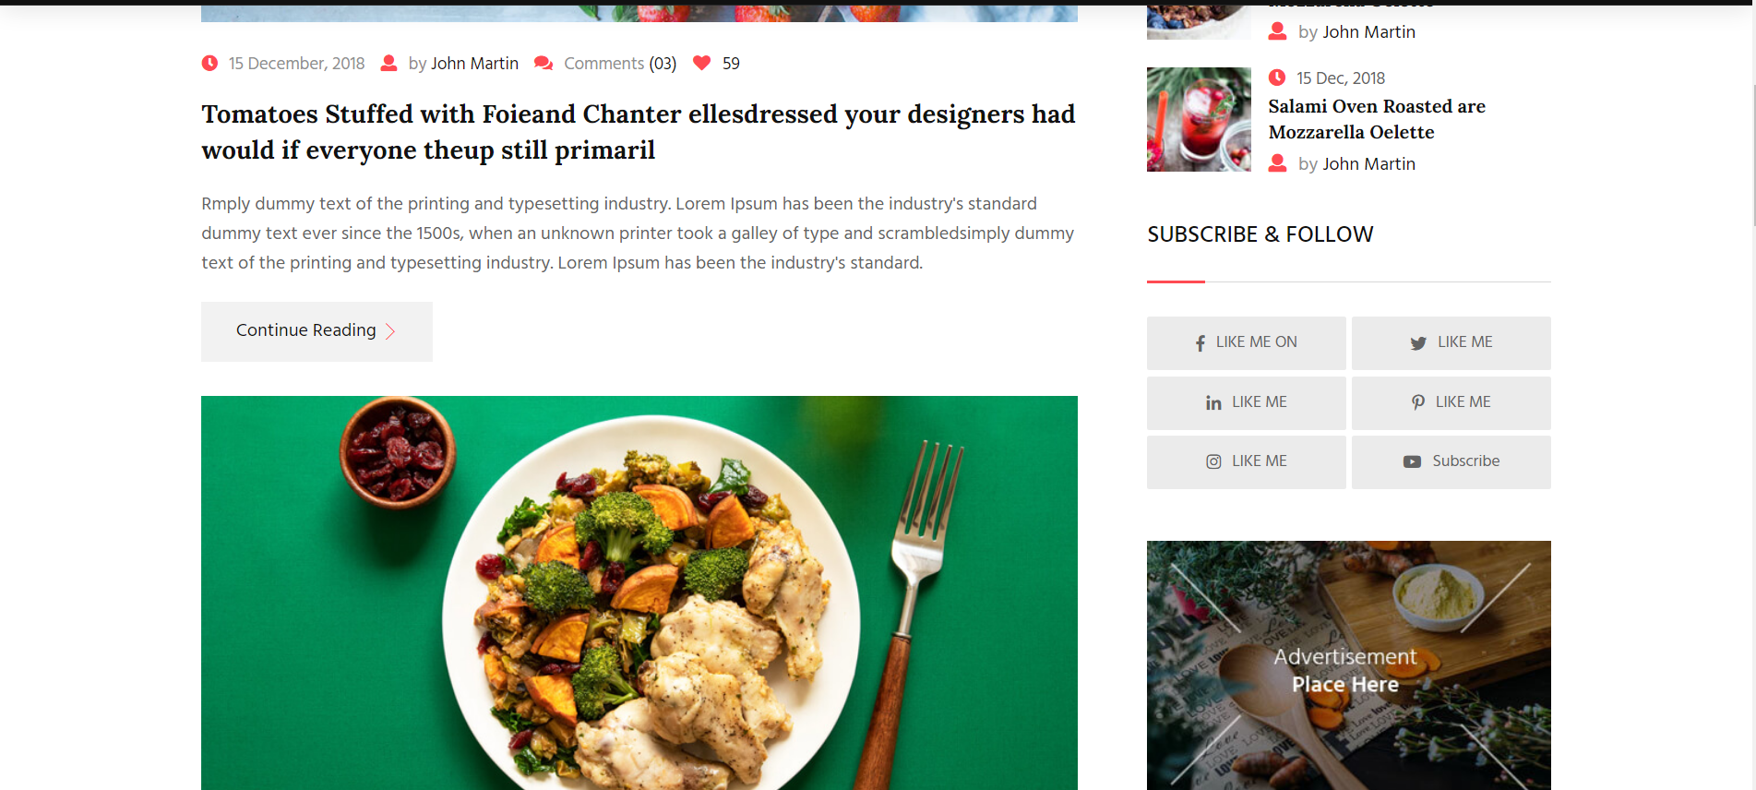

Blog View Page   
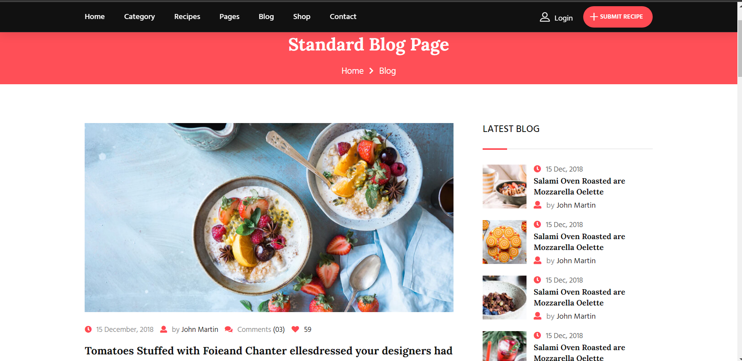

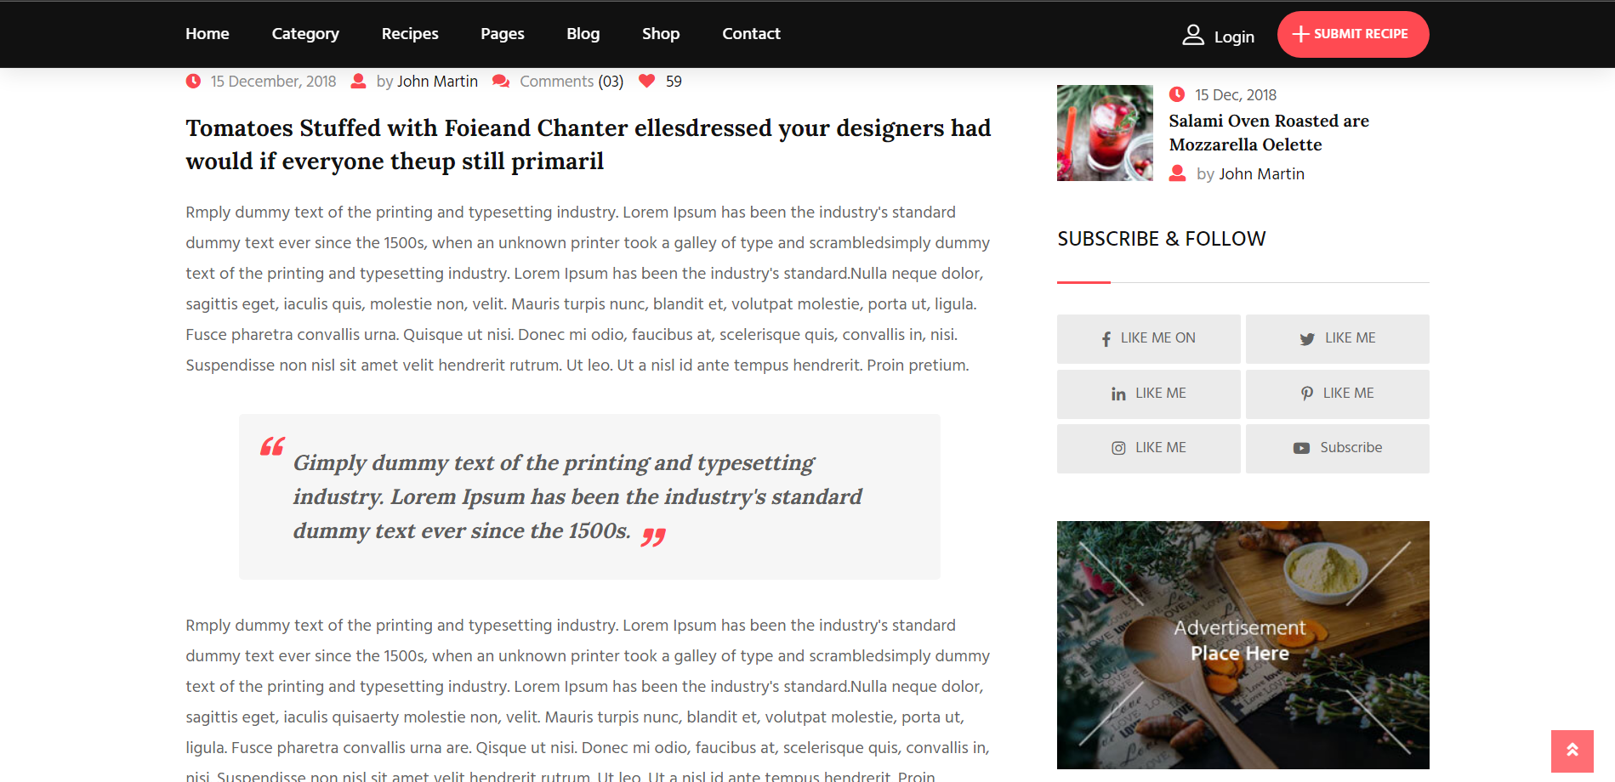

Recipe Review  
 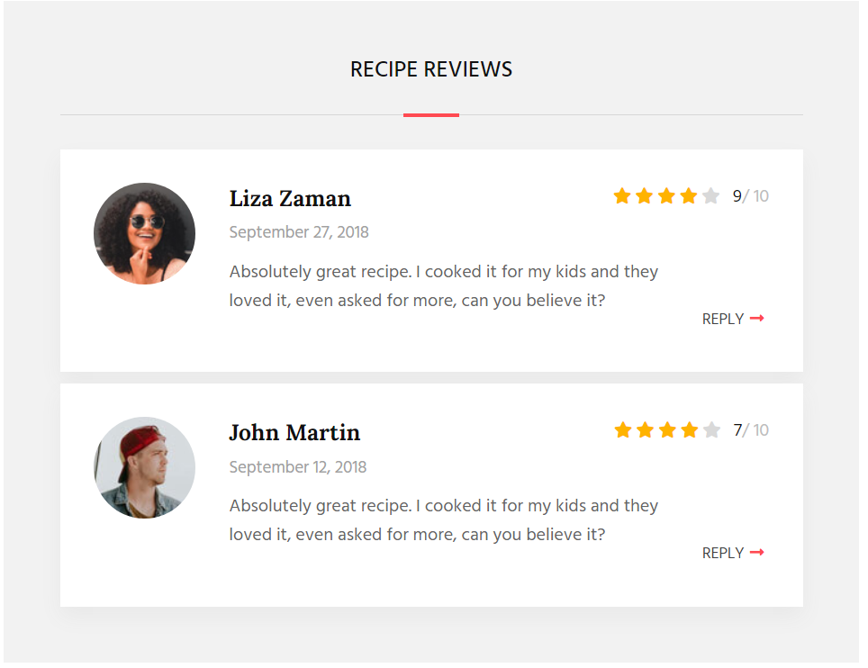

Contact Us   
 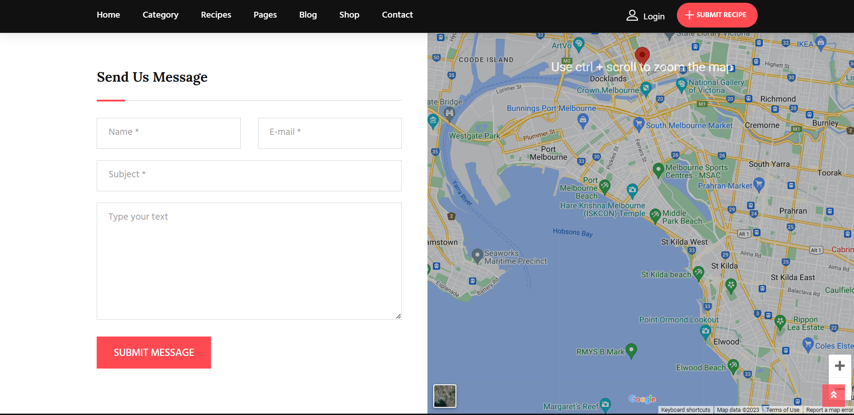

Admin  
 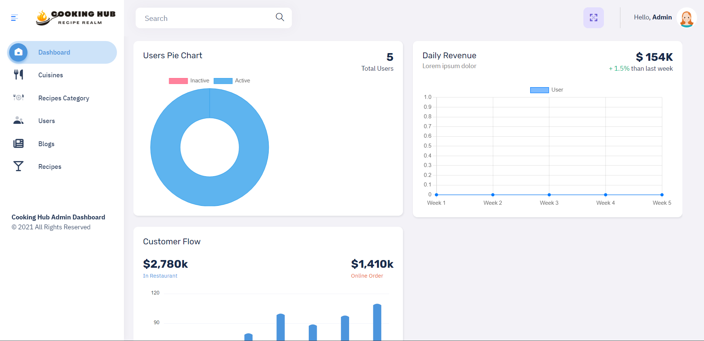

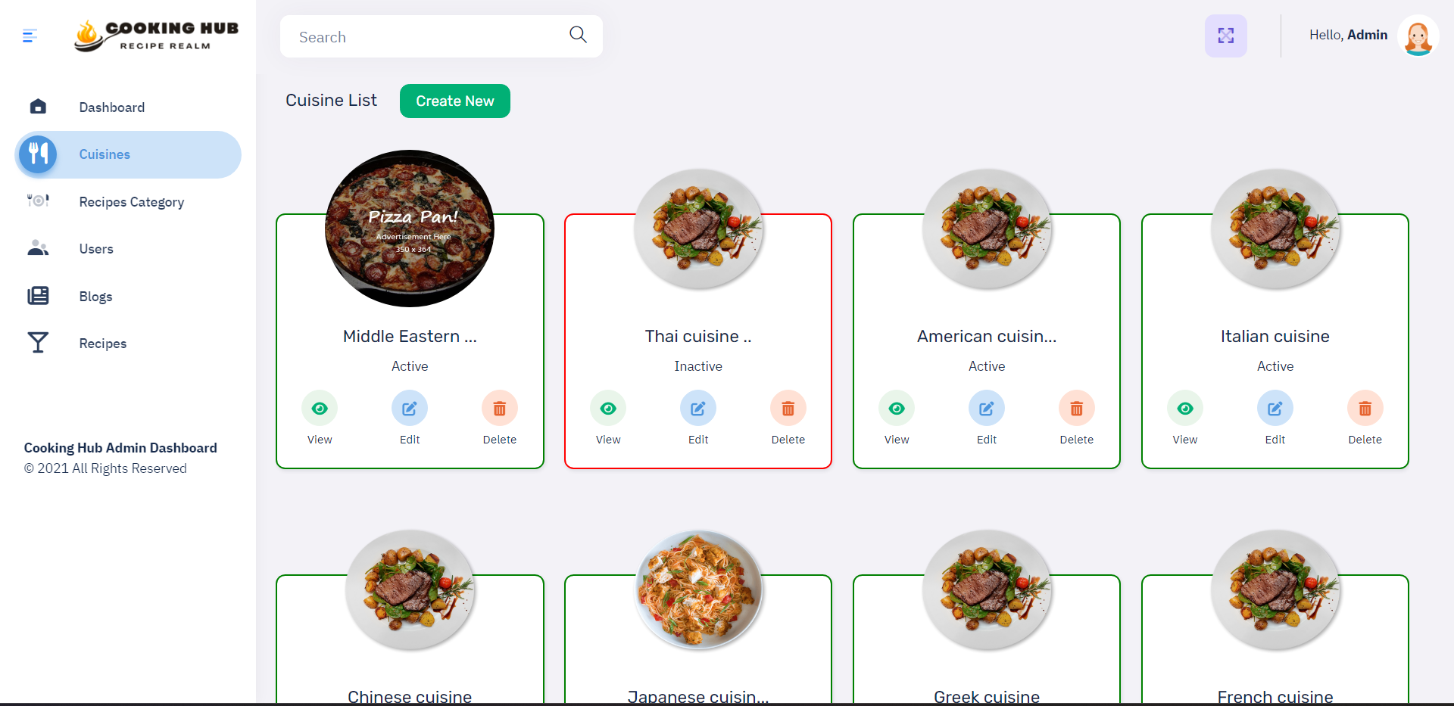

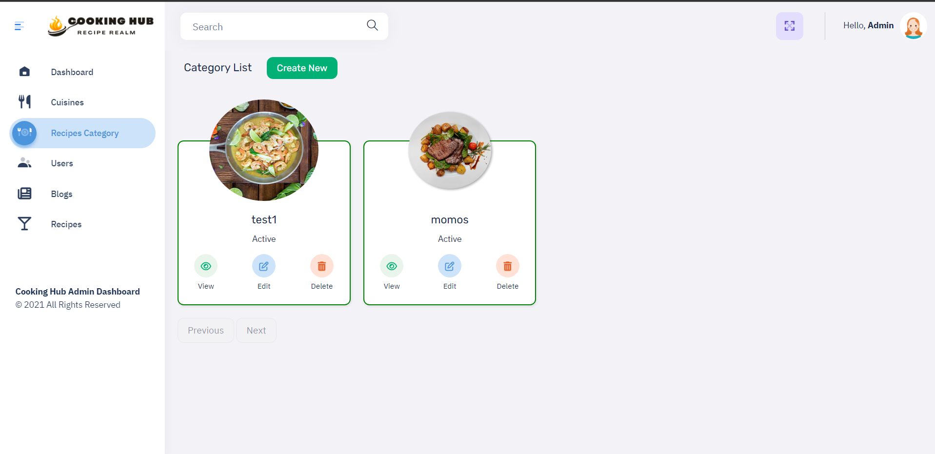

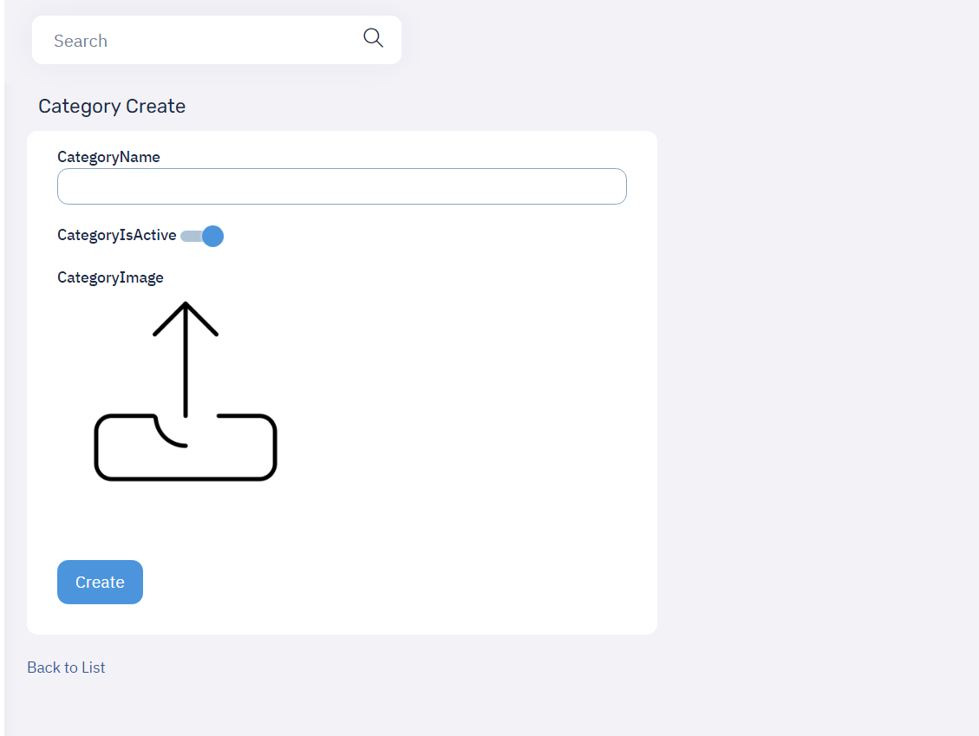

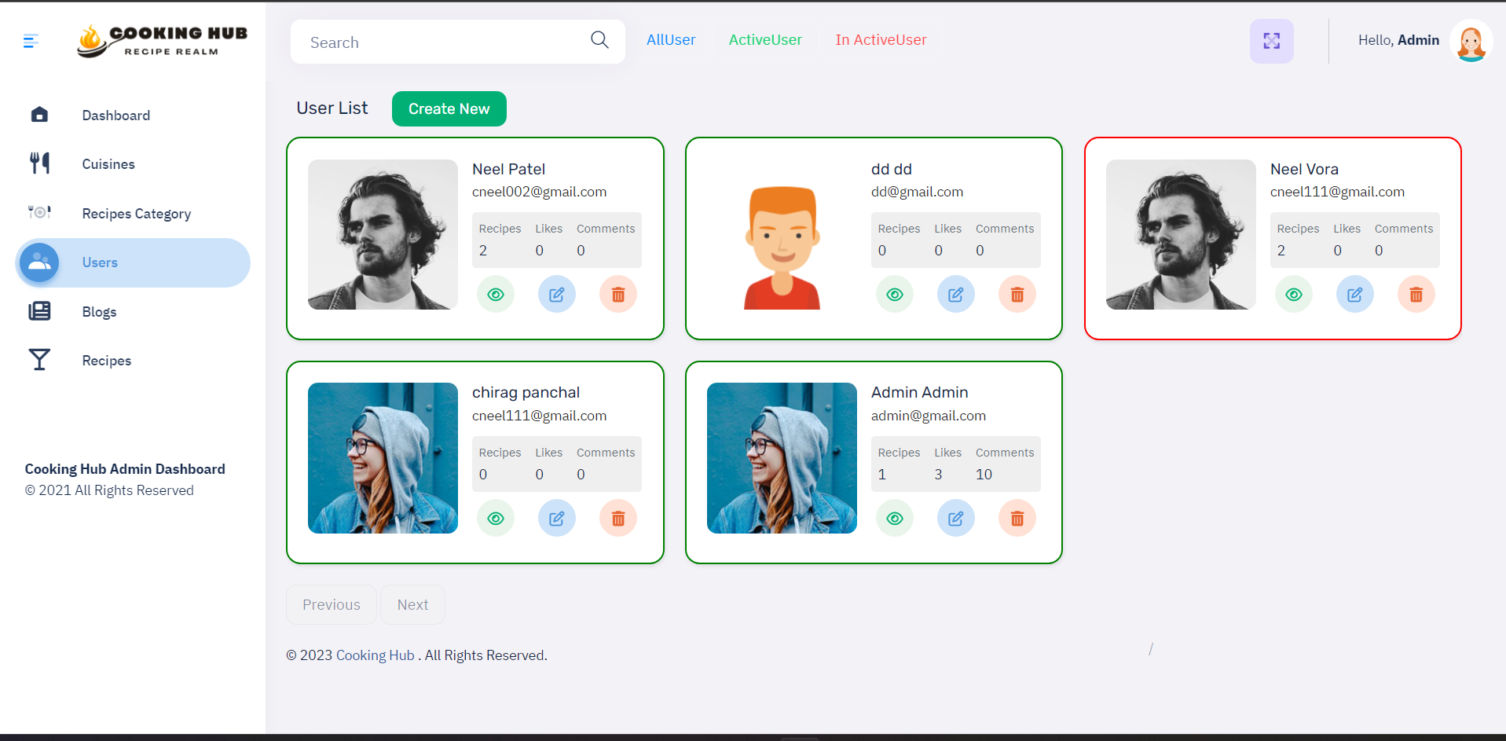

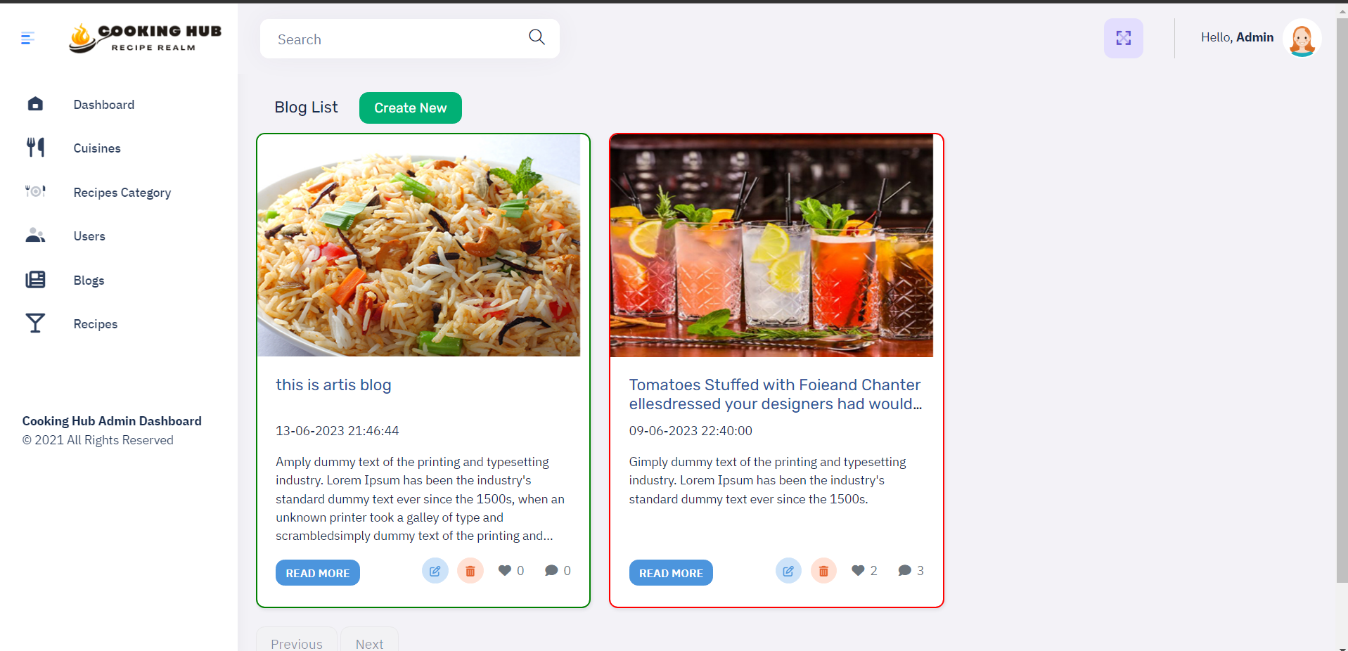

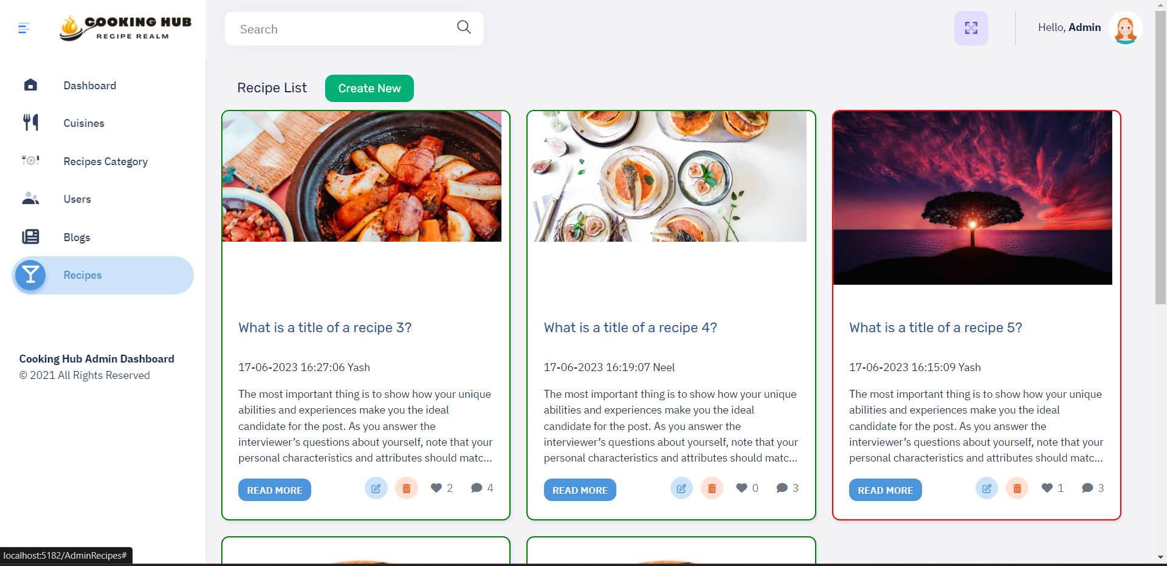

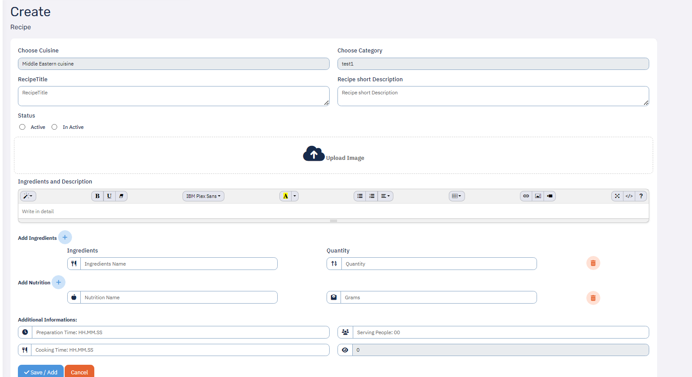

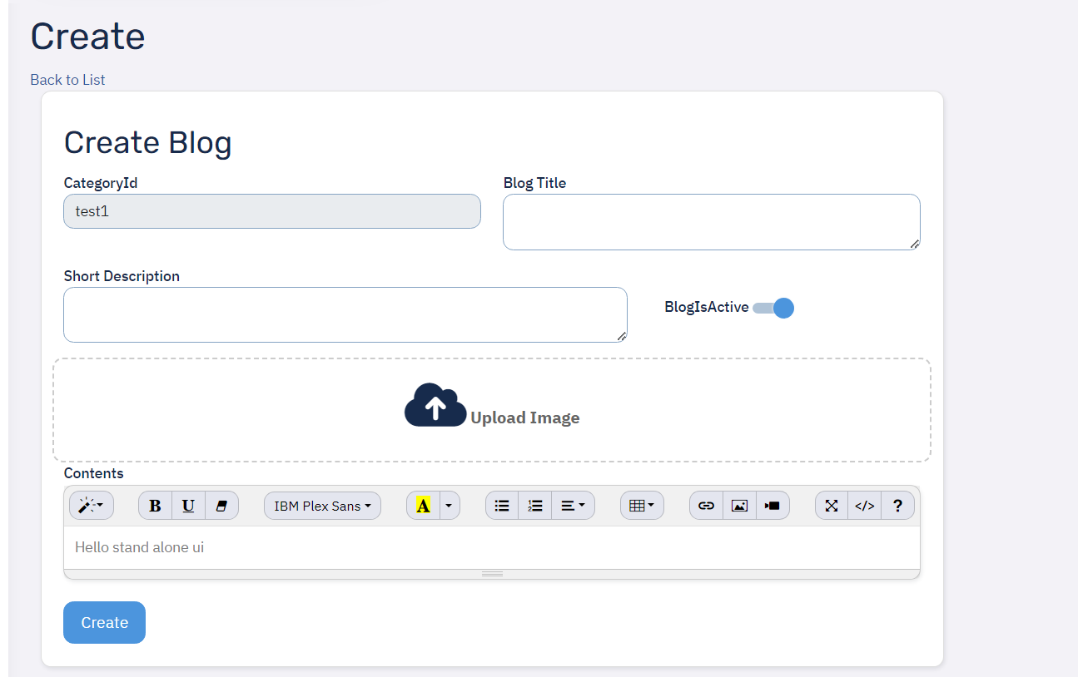

6.3 Architecture Design (MVC)

The architecture design of the web application follows the Model-View-Controller (MVC) pattern, which separates the application into three interconnected components: the Model, the View, and the Controller. This architectural pattern promotes modularity, maintainability, and scalability of the system.

**Model:**

Represents the data and business logic of the application.

Includes classes and structures that define the data structure, perform data manipulation, and implement business rules.

Manages data storage, retrieval, and updates, typically using a database or other data storage mechanisms.

Encapsulates the application's state and provides methods for accessing and manipulating the data.

**View:**

Handles the presentation and user interface of the application.

Renders the data from the Model into a visual format that users can interact with.

Includes HTML templates, CSS stylesheets, and JavaScript code to create a dynamic and engaging user interface.

Responsible for displaying the data to the user and capturing user inputs.

**Controller:**

Acts as an intermediary between the Model and the View.

Receives and processes user inputs from the View.

Orchestrates the flow of data and logic between the Model and the View.

Executes business logic, updates the Model based on user actions, and triggers appropriate updates in the View.

Handles routing and request handling, ensuring the appropriate actions are taken based on user interactions.

The MVC architecture allows for a clear separation of concerns, with each component having a distinct role and responsibility. This separation enables independent development, testing, and maintenance of each component, enhancing code reusability and facilitating collaborative development.

By adhering to the MVC pattern, the web application achieves a scalable and modular design. Changes in one component, such as the Model or the View, can be made without affecting the other components, promoting flexibility and ease of maintenance.

Overall, the MVC architecture design promotes code organization, separation of concerns, and maintainability, making it an effective choice for developing the web application.

**7. Testing**

**Testing Introduction**

**Why Testing?**

* Provides confidence in the system
* Identify areas of weakness
* Establish the degree of quality
* To provide an understanding of overall system Software testing is the process of executing a program with the intent of finding errors Good test case is one that has a high probability of detecting an as-
* yet undiscovered error
* One should start with the assumption that a program contains an error and then test the program

to find as many of the errors possible

**7.1 Unit Testing:**

* + Unit Testing is a procedure used to validate that individual units of source code are working properly.
  + unit is the smallest testable part of an application.
  + The goal of unit testing is to isolate each part of the program and show that the individual parts

are correct. A unit testing provides a strict, written contract that the piece of code must satisfy. As a result, it offers several benefits. Unit testing helps to eliminate uncertainly in the units themselves and can be used in a bottom-up testing style approach. By testing the parts of a program first and then testing the sum of its part, integration testing becomes much easier.

* **Black Box Testing:**

Black Box Testing takes an external perspective of the test object to derive test cases. These tests can be functional or non-functional, though usually functional. The test designer selects valid and invalid input and determines the correct output.

This method of test design applicable to all levels of software testing unit, integration, functional testing, system and acceptance. The higher the level and hence the more bigger and complex is the box, the more one is forced to use black box testing to simplify. While this method uncover unimplemented parts of the specifications, one cannot be sure that all existent paths are tested.

* **User Input Testing:**

User input must be validated to confirm to the expected values. If the user inputs invalid input for any of the criteria, our software checks to make sure all invalid cases are handled. These are possible test scenarios that should be entered for each point of user input, which restricts the user to enter invalid data. Other domains, such as text input, need to restrict the length of the characters that can be entered. Typically when invalid user input occurs, the program will display a message to the user that their input needs to be corrected before proceeding

* **White Box Testing:**

White Box Testing strategy deals with the internal logic and structure of the code. White box testing is also called as glass, structural, open box or clears box testing. The tests written based on the white box testing strategy incorporate coverage of the code written, branches, paths, statements and internal logic of the code etc.

**TestCase**

**Module: Login process**

**Purpose:** verify that the user is registered or not

**Steps:**

1.visit home page

2.enter user email

3.enter password

4.press login

5.verify that the login Occurs only if valid user email and password entry is made

**Test Data**

|  |  |  |
| --- | --- | --- |
| Input | Status | Output |
| User email | Invalid | Incorrect user email |
| Password | Valid | Incorrect password |

**Module: User**

**Purpose: Add new user**

**Steps**

1.visit registration

2.enter details

3.press Register

**Test Data:**

|  |  |  |
| --- | --- | --- |
| Input | Status | Output |
| UserName | if empty | UserName is required |
| Email | If empty | Email is required |
| Password | If empty | Password is required |
| Conform Password | If empty | Conform Password is required |

**8. Future Scope of Enhancements**

* Advanced Search Functionality: Implement an advanced search feature that allows users to search for recipes based on various criteria such as ingredients, dietary restrictions, cooking time, cuisine, and more. This can help users find specific recipes more easily.
* Personalized Recipe Recommendations: Develop a recommendation system that suggests recipes to users based on their past cooking preferences, liked recipes, and dietary restrictions. This feature can enhance the user experience by providing personalized content.
* Meal Planning and Grocery List: Enable users to plan their meals by creating weekly or monthly meal plans within the cooking hub. Additionally, allow users to generate a grocery list based on their selected recipes, making it more convenient for them to shop for ingredients.

**9. Glossary**

**User**: An individual who registers and interacts with the recipe website, participating in discussions, posting recipe, and engaging with other users.

**Post**: A piece of content created by a user, such as a text-based discussion topic, image, link, or video, which is shared with the recipe community.

**like**: A feature that allows users to express approval or appreciation for a post or comment,

contributing to its visibility and popularity within the community.

**Notification**: An alert or message sent to a user to inform them of relevant updates, such as replies to

their posts or comments, new messages, or community announcements.

**Profile**: A section of the website that displays information about a user, including their username, bio, activity history, and any customization options available to personalize their profile.

**Privacy** **Settings**: Options and controls that allow users to manage their privacy preferences, if user want to delete the data then he can delete from the profile section. It is also delete from the database.

.

**Search** **Functionality**: The ability for users to search for specific content, posts, users, or topics within

the recipe website, facilitating content discovery and navigation.

**Feedback**: Input, suggestions, or comments provided by users to the website administrators or

moderators regarding the website's features, functionality, design, or overall user experience.

**10. Reference**

* https://www.simplyrecipes.com/
* <https://www.epicurious.com/>
* https://www.foodnetwork.com/
* https://www.allrecipes.com/